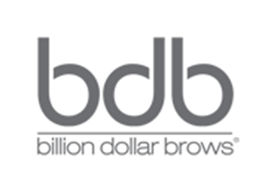
- Steps to Beautiful Brows Kit
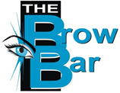
- a product from Billion Dollar Brows
Brought to you exclusively by

“Beautiful brows are a right, not a privilege…”

Condition, Colour, and Control Your Brows. This kit will give you the beautiful brows you want in three simple steps.

Condition:
Our deep conditioning treatment is designed to help strengthen & condition Thin, over-tweezed brows. A natural formula with no scary side effects, you will see visibly fuller brows in as little as 30 days. Depending on individual use, this bonus size edition will last at least 60 days.
Colour:
The Universal Brow Pencil. No more guessing games! Formulated to work with all skin tones & hair colours. This amazing pencil goes on smooth and natural. Perfect for creating beautiful, natural brows for when you’re on-the-go. The pencil’s versatile colour works with almost all hair colours and skin tones. Use the brush on the opposite end of the pencil to blend to perfection!
Control
Our Brow Gel will lock in your look, giving your eyebrows a long-lasting, radiant glow while keeping them perfectly in place all day. It’s the perfect finishing touch for giving your brows a polished, perfectly manicured look. This bonus size Brow Gel will, depending on individual use, last at least 60 days.
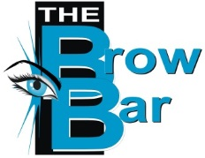
Bonus size Brow Booster and Bonus size Brow Gel included in every promotional pack!!

Tel: (011) 675 2624 Address: Entrance 3 shop Im 094
Cel: (+27) 84 786 2701 Clearwater Mall, Roodepoort, JHB
Email: info@thebrowbar.co.za
Website: www.thebrowbar.co.za

